**Approximating species age under different speciation modes and extinction**

Carlos Calderón del Cid1,2, Torsten Hauffe2, Juan D. Carrillo2, Daniele Silvestro2,3

1Laboratório de Ecologia Espacial, Instituto de Biologia, Universidade Federal da Bahia, CEP 40170-110, Salvador, Bahia, Brasil

2Department of Biology, University of Fribourg, Switzerland and Swiss Institute of Bioinformatics, Fribourg, Switzerland

3Department of Biological and Environmental Sciences and Gothenburg Global Biodiversity Centre, University of Gothenburg, Sweden

**Abstract**

Species age (the elapsed time since origination) can give an insight into how species longevity might influence eco-evolutionary dynamics. Traditionally, species ages have been measured in the fossil record; however, recently, researchers have estimated the ages of extant species from the branch lengths of time-calibrated phylogenies. This approach poses problems because phylogenetic trees typically do not contain direct information about speciation mode, extinctions, and incomplete sampling. When phylogenies do not include extinct or extant lineages, the branch lengths of extant species are likely to appear longer than they truly are. Additionally, different speciation modes (i.e., bifurcating, budding, or anagenetic) cause different topological representations of phylogeny and, thus, affect the relationship between branch lengths and species age. Here we evaluate through simulations the effect of extinction, incomplete sampling, and speciation mode on the accuracy of phylogenetic ages as proxies for the true ages of extant species and we quantify the consequences on eco‑evolutionary inferences. We show that the three noted problems greatly influence the accuracy of phylogenetic ages. The error is substantially higher under budding than bifurcating speciation and further increased when we contemplated incomplete sampling and higher extinction. . We found that this mismatch would affect eco-evolutionary analyses often performed with phylogenetic ages, for instance, the comparison of species ages and the assessment of extinction risk. For bifurcating speciation, which is most often assumed in these analyses, we develop a probabilistic approach to improve the estimation of species ages, based on the properties of a birth-death process and under the assumption of a full sampled phylogeny. We find that our model can reduce the error by one order of magnitude under cases of high extinction. Our results indicate that we should be cautious when inferences are made from the relationship between phylogenetic ages and eco-evolutionary variables, and that, under some assumptions, it is possible to obtain good approximations of species age by combining branch lengths with the expectations of a birth-death process.

**Key words:** Evolutionary history, Extinction rates, Incomplete sampling, Simulations, Speciation modes, Phylogeny.

**Introduction**

The estimation of species age, or the elapsed time since species origin, is important to evaluate mechanisms that link species longevity with eco-evolutionary processes (Benton, 2013; Swenson, 2019). For instance, age-dependent extinction hypotheses test the relationship between species age and extinction probability, assessing whether extinction rates differ between young vs old species (Balmford, 1996; Eldredge et al., 2005; Pearson, 1995). Likewise, species age could be a measure of colonization time, especially in island systems (Tanentzap *et al.* 2015) or during biotic invasions triggered by geological events, such as the formation of the Central American Isthmus for the Great American Interchange (Carrillo *et al.* 2015, 2020). Species age is measured in the fossil record through different statistical and probabilistic approaches based mostly on taxa’s stratigraphic duration (Foote, 1996; Foote & Raup, 1996). Several of these approaches consider the differences in fossil sampling and temporal resolution (Alroy et al., 2001; Silvestro et al., 2019). Species ages estimated from paleobiological data offer a reliable measure of species’ temporal duration which can be used in macroevolutionary studies (Benton, 2016; Silvestro et al., 2020; Van Valen, 1973). More recently, several studies have used the length of terminal branches in time-calibrated phylogenies as a proxy for the age of extant species (Davies et al., 2011; Gaston & Blackburn, 1997; Johnson et al., 2002; Pie & Caron, 2023; Sonne et al., 2022; Tanentzap et al., 2020; Verde Arregoitia et al., 2013). However, this approximation, which we hereafter refer to as “phylogenetic age”, can lead to over or underestimations due to three non-exclusive shortfalls.

First, incomplete sampling of extant species can bias phylogenetic age estimation by augmenting terminal branch lengths (Heath et al., 2008; Mynard et al., 2023). Second, extinction events will mask branching events in phylogenetic trees of extant species (Harvey et al., 1994; Nee & May, 1997). Even in phylogenetic trees that include extinct taxa, the incompleteness of the fossil record will inevitably lead to missing lineages and uncertain topologies. Unsampled extant and extinct species from the phylogeny results in an inflation of the length of terminal branches leading to sampled species (i.e., the tips of the tree), thus altering phylogenetic species ages. For instance, if the extinct species of the *Homo* genus are not included in a phylogeny, the phylogenetic age of *Homo sapiens* is approximately 10 million years, i.e., the age of the last common ancestor with its sister species, the chimpanzee (Rivas-Gonzáles et al. 2023). This estimate exceeds the age of the oldest known fossil of modern humans by two orders of magnitude (Figure 1; Callaway 2017). The third, and perhaps most challenging shortfall in phylogenetic species ages, is that the tree alone does not contain information about the underlying speciation mode and does not include species labels across its branches, such that only the tips can be unequivocally assigned to a named species (Losos & Glor, 2003). Alternative speciation modes have been discussed in the literature reflecting different biological processes and species concepts, including bifurcating, budding, and anagenetic speciation (Foote, 1996; Silvestro et al., 2018). These modes define the relationship between the ancestral species and its descendants, thus contributing to determining species ages (Rosenblum et al., 2012; Wagner, Erwin, & Anstey, 1995) (Fig. 2). Most phylogenetic trees are depicted in the rectangular shape where the two descending lineages split symmetrically from an ancestral lineage, thus suggesting a bifurcating speciation mode where two new species replace the ancestral lineage (Baum et al., 2005; Caetano & Quental, 2022). However, the often-unstated assumption of all birth-death processes commonly used to model phylogenetic branching times, is that speciation occurs as a budding process, with a speciation event leading to a single new species and the survival of the parent species, even though we can’t say which descendant branch is the “new” species. Anagenetic speciation, in contrast, does not lead to a branching event and is therefore not visible on a phylogenetic tree.

All speciation modes may reflect plausible biological processes, and evidence for each mode has been found in the fossil record (Foote, 1996; Simpson, 1984) and in extant species (Skeels & Cardillo, 2019). Bifurcating speciation can be linked with vicariance or allopatric speciation (Willmann & Meier, 2000), and the Hennigian species concept considers all speciation events as bifurcating (Henning, 1999). Under this speciation mode, phylogenetic ages equal species ages when there is no extinction and all species are sampled. Budding speciation can be interpreted as the result of parapatric, peripatric, and founder-event speciation (Anacker & Strauss, 2014; Caetano & Quental, 2022) and is related to the evolutionary species concept, which considers any species as descendant of an ancestral lineage with its own evolutionary identity (Simpson 1951, but see Simpson 1961). A phylogenetic tree typically lacks information about which of the two descendent branches is the new species after a speciation event (but see Aze *et al.* 2011). Thus, in the absence of extinction, the phylogenetic age of one sister species will equal its species age while the other will be older but without the possibility to identify which one is which. Anagenetic speciation is not associated with a branching event but can be used to describe different species or morphospecies (Emerson & Patiño, 2018) delimited by substantial phenotypic change occurring along a lineage (Roopnarine et al., 1999) and will cause a higher phylogenetic age than the genuine species age.

Several studies used phylogenetic age at face value for species age (e.g., Johnson et al. 2002; Tanentzap et al. 2020; Verde Arregoitia et al. 2013), but the potential deviation from the true species ages due to the combined shortfalls referred above is unknown. Here we use simulations to quantify the predictability of species age from phylogenetic trees of extant taxa, under different diversification scenarios. Specifically, we performed simulations where we know the true age of species to: (1) quantify the error in phylogenetic ages under various scenarios combining different speciation modes with a range of speciation and extinction rates; (2) examine whether this error affects our ability to make qualitative decisions on the order of species ages; (3) quantify the error in phylogenetic ages under three different levels on incomplete sampling combined with bifurcating and budding speciation in an intermediate extinction scenario; and, (4) explore whether the signal of labeled age-correlated extinction risk is preserved in the phylogenetic age of species, given three different extinction scenarios and three different percentages of incomplete sampling. Finally, we propose a new method to more accurately estimate species age under the assumption bifurcating speciation, which is the most widely used assumption in eco-evolutionary studies (e.g., Tanentzap et al. 2020).

**Methods**

*Simulating species ages*

We generated complete phylogenies of extant and extinct species under a stochastic birth-death process using the package TreeSim 2.4 (Stadler, 2010) for the R 4.3.0 statistical programing environment (R Core Team 2023). Regarding the number of extant species, we ran two types of simulations depending the shortfalls we intended to evaluate. For speciation modes, we simulated for all trees 100 extant species. For incomplete sampling, we had three levels and kept the trees’ size constant (100 species) after subsampling: (1) for “0% missing species”, we simulated all trees with 100 extant species; (2) for “25% missing species”, we simulated all trees with 134 species; and (3) for “50% missing species”, we simulated all trees with 200 species. Regarding extinction rates, we ran two types of simulations; for the first group, we explored the extinction rates continuously to evaluate how impacts quantitatively the species age estimation, and, the for second one, we set three discrete extinction scenarios, to evaluate how fixed extinction scenarios affected qualitatively the species age estimation. Then, we mapped species on the complete phylogenies using the R package FossilSim 2.3.1 (Barido-Sottani et al., 2019) under different speciation modes, thus assigning species labels across all branches of the tree. We used the labels assigned to terminal extant taxa to determine the true species ages. We then dropped all extinct species from the tree and obtained the length of terminal branches, to quantify the phylogenetic age of extant species. Finally, we rescaled all phylogenetic trees to a root age of one, so that phylogenies were comparable to each other, and compared the relative true and phylogenetic ages among different simulation scenarios.

*Error in equating phylogenetic and species age*

To explore whether there is a consistent over- or underestimation of species ages and to quantify error in approximating species ages with phylogenetic ages, we simulated a range of datasets with different speciation modes and diversification rates. First, we simulated 3 sets of 100 phylogenetic trees with birth rates defined to 0.1, 0.5, and 1, combined with 100 death rates ranging from 0 to 0.99 in equal increments (Beaulieu & O’Meara, 2016). Second, on each of these phylogenies, we then mapped species according to different scenarios of speciation: (1) budding speciation, (2) bifurcating speciation, (3) a combination of budding speciation and anagenetic speciation with the rate of anagenesis set to half of the birth rate, and (4) bifurcating speciation combined with anagenetic speciation with the rate of anagenesis set to half of the birth rate.

Across all trees, we obtained in total 120,000 extant species, 30,000 for each speciation scenario. For each speciation mode and extinction fraction rate (defined as death/birth Beaulieu & O’Meara, 2016), we calculated the mean absolute percentage error (MAPE) across all species for each tree as measure of the deviation between the phylogenetic ages from the true age.

MAPE =

Next, for each speciation mode, we plotted the MAPE against the simulated extinction fraction.

*Impact of age error in comparing species ages*

To explore whether the error introduced by approximating species age with phylogenetic age impacts our ability to make qualitative judgements such as which of two extant species is the younger one, we simulated 1,000 phylogenetic trees with values of extinction fractions of 0.9, 0.5, and 0, combined with a fixed speciation rate of 1 (3000 trees). Second, on each of these phylogenies, we mapped species according to budding and bifurcating speciation. Thus, we simulated 300,000 extant species for each speciation mode. Next, we calculated the proportion of cases where the younger of two species, according to its phylogenetic age, is, in fact, the older one given the true age of the two species. We performed this comparison from the perspective of an empirical research that can only obtain the phylogenetic ages. We made two types of comparisons for each phylogeny: (1) between the youngest and oldest species in the phylogeny, and (2) between two randomly selected species.

*Error in the phylogenetic age due to uniform incomplete sampling*

We used the intermediate extinction scenario of the previous section to explore the combined effect of three levels of uniform incomplete sampling, 0%, 25% and 50%, and bifurcating and budding speciation on equating phylogenetic and true age. We calculated the MAPE for each tree as the difference between phylogenetic and true age, and compared the incomplete sampling scenarios for each speciation mode.

*A probabilistic method to infer species age*

Under the assumption of bifurcating speciation, the phylogenetic age represents the upper boundary of plausible species ages and corresponds to the true age in the absence of extinction. However, the true age could be younger if extinction led to the disappearance of recent cladogenetic events from the phylogeny of extant species. Given a phylogenic age *vi* the probability that the true species age *si* is exactly *vi* is conditional on no other speciation or extinction event having occurred between *vi* and the present. We approximate the probability of no speciation or extinction for an arbitrary small time bin *t* based on the probability that a lineage results in a single descendant, which is (Kendall, 1946):



based on a birth-death process with time-homogenous speciation rate λ and extinction rate μ. The probability that no event occurs over a time window *v, i.e.,* until the age of the observed node *i*,is approximated as:



In the absence of extinction (μ = 0), the probability of the true species age *si* to be equal to *vi* is 1, because any speciation event following the node *vi* would be observed in the tree of extant species. Thus, we calculate the normalized probability of the speciation event to occur at time *vi* as:

 (1)

We then compute the probability of a speciation time for any given time *τ* as:

 (2)

Where the first term quantifies the probability of the species age a long a vector of times, while the second term normalizes it after accounting for the probability that speciation occurred exactly at the node. We use equations (1) and (2) to approximate density describing the probability of a species origination at the observed phylogenetic age and along the branch connecting the node with tip. As point estimates of the species age, we tested the mean and the median of the distribution.

To evaluate the accuracy of our probabilistic species age estimator, we simulated 1,000 phylogenetic trees with extinction rates of 0.25, 0.15, and 0.05, and a fixed speciation rate of 0.3. Then, using the phylogenies as inputs, we mapped species on each tree based on a bifurcating speciation process. Then, we calculated the MAPE for each tree as measure of the deviation between the function’s estimated and the phylogenetic ages from the true age.

*Imprint of extinction risk on phylogenetic ages and the corrective probabilistic method*

To evaluate whether the erroneous estimation of species age, due to the extinction shortfall, has material consequences over eco-evolutionary relationships, we explored the assumed relationship between species age and present extinction risk (e.g., Johnson et al. 2002; Tanentzap et al. 2020; Verde Arregoitia et al. 2013).We used the same phylogenies and taxonomies (assuming bifurcating speciation) generated in the previous section. Next, we binned the true ages of extant species in five categories corresponding to the IUCN conservation categories: Least Concern (LC), Near Threatened (NT), Vulnerable (VU), Endangered (EN), and Critically Endangered (CR; International Union for the Conservation of Nature 2016). With this, we generated a positive effect scenario with older species being at higher risk regarding the IUCN categories. Then, we quantified the error rate for the phylogenetic and the probabilistic species age estimator, as the share of the 1000 datasets where the ranking of mean age per conservation status category did not match with the simulated monotonic increase.

*Imprint of extinction risk on phylogenetic ages given three levels of nonrandom incomplete sampling*

To explore whether the erroneous estimation of species age, due to nonrandom incomplete sampling, has consequences over the inference of the assumed relationship between species age and present extinction risk, we used the intermediate extinction scenario phylogenies and the taxonomies assuming all speciation occurs via bifurcation or budding. Then, to simulate three levels of nonrandom incomplete sampling (0%, 25%, 50%), we implemented a function to remove species with a probability proportional to its age, i.e., older species are less likely to be sample. Next, we binned the true ages of extant species in five categories corresponding to the IUCN conservation categories: Least Concern (LC), Near Threatened (NT), Vulnerable (VU), Endangered (EN), and Critically Endangered (CR; International Union for the Conservation of Nature 2016). With this, we generated a positive effect scenario with older species being at higher risk regarding the IUCN categories. Then, we quantified the error rate for the phylogenetic age in the three incomplete sampling scenarios for bifurcating and budding speciation mode, as the share of the 1000 datasets where the ranking of mean age per conservation status category did not match with the simulated monotonic increase.

**Results**

*Error in equating phylogenetic and species age*

Under the assumption of bifurcating speciation and with no extinction events, phylogenetic ages matched the true age of extant species (Figure 3). At low extinction fraction (< 0.25), 96% of the phylogenetic age estimations were congruent with the true age. At high extinction fraction (> 0.75), this was also the case for most species (73%). However, age overestimation increased with extinction fraction and in some cases the phylogenetic age erroneously suggested that the species is as old as the root age. Under bifurcating speciation, the phylogenetic age never underestimated the true species age, while in the case of budding speciation over- and underestimation occurred. Also, the proportion of cases were the phylogenetic ages equal the species age was lower than in the bifurcating scenario. Regarding budding speciation, overestimated ages were more frequent with high extinction while underestimations occurred with low extinction but in principle both happened under all extinction scenarios (Figure 3). Even at low extinction fraction, ~50% of phylogenetic ages did not match the true ages. With higher extinction fraction, phylogenetic ages overestimated true age more often (17%).

In datasets simulated under a mixture of anagenetic and bifurcating speciation, phylogenetic ages deviated more strongly from the true ages than under a pure bifurcating process, given that anagenetic events are unobserved in the phylogeny (Figure S1). In a low extinction fraction scenario, phylogenetic ages were congruent with the true species ages 78% instead of 96% of the cases, and with high extinction the share decreases from 73% to 62%. Datasets with mixed anagenetic and budding speciation, phylogenetic ages also deviated more that under a pure budding process; in a low extinction scenario, phylogenetic ages were congruent 40% instead of 50%, and with high extinction the accuracy decreased to 34%.

While a budding speciation mode led to a higher baseline error than bifurcation, the latter showed a stronger increase with extinction fraction (Figure 4). Under both modes of speciation, speciation rates did not have a substantial impact on error in age. For strictly bifurcating speciation, there was no error in the absence of extinction, but the MAPE increased to up to 150% with extinction fractions exceeding 0.75 (Figure 4a). In contrast, under budding speciation the MAPE was around 25% in the absence of extinction, increasing to 30-120% with extinction fractions exceeding 0.75 (Figure 4b). In datasets that included anagenetic speciation, the MAPE reached as high as 500% in some simulations (Figure SM2).

*Impact of age error on comparing species ages*

For the combination of strictly bifurcating speciation and all extinction scenarios, selecting the phylogenetically youngest and oldest species never resulted in a case where the presumed older species has been in fact the younger of the two species according to their simulated age (Figure 5a). Thus, for this speciation mode, there is no risk of a qualitative error when comparing species at the extremes of the age range of a time-calibrated phylogeny. In contrast, for budding speciation, the age rank of the oldest and youngest species was erroneously determined in 2.2% of the simulations in the absence of extinction, increasing to 7.5% and 12.2% for intermediate and high extinction, respectively (Figure 5b).

Under bifurcating speciation, the age ranking of two randomly selected was incorrect in 6% and 8%, for intermediate and high extinction, respectively (Figure 6a). Under budding speciation, the error exceeded 25%, irrespectively of the extinction level (Figure 6b).

*Error on equating phylogenetic and species age given uniform incomplete sampling*

Under bifurcating speciation, the MAPE for trees completely sampled was 25 ± 20 %; for trees missing 25% of extant species was 362 ± 1406 %; and for trees missing 50% of extant species was 2120 ± 18950 % (Figure 7a). Under budding speciation, the MAPE for trees completely sampled was 42 ± 15 %; for trees missing 25% of extant species was 209 ± 847 %; and for trees missing 50% of extant species was 909 ± 8961 %.

*Probabilistic species age estimation*

In a low extinction scenario, the phylogenetic age MAPE (7.7 ± 15 %) was lower than both point estimates of the probabilistic function, 10.7 ± 10 % and 8.3 ± 15 % for expected and median age, respectively (Figure 8a). In an intermediate extinction scenario, both expected (22.6 ± 14 %) and median age (18.2 ± 17.7 %) presented a slightly lower MAPE than phylogenetic age (25.9 ± 22 %; Figure 8b). Finally, in a high extinction scenario, both point estimates MAPE, expected (30.7 ± 13 %) and median (25.3 ± 14 %), presented a two-fold decrease regarding the phylogenetic age (60.2 ± 38 %; Figure 8c).

*Effect of approximate species age on estimated extinction risk correlations*

The use of phylogenetic age as an approximation of species age led to error rates of 1.3, 7.2, and 18.6 % for scenarios with low, intermediate and high extinction rates, respectively (Figure 9). Thus, even under intermediate extinction the true relationship between age and conservation status was wrongly estimated in a significant fraction of the simulations, and higher extinction rates led to a further substantial drop in the reliability of this approach. In contrast, estimating species ages based on our probabilistic method led to much lower error rates (3 to 4-fold) that dropped to 2% and 4% with intermediate and high extinction, respectively.

*Effect of nonrandom incomplete sampling on the correlation between species ages and extinction risk*

Under bifurcating speciation, the use of phylogenetic age as an approximation of species age for assessing extinction risk categories led to error rates of 6.2%, 12.8%, and 49.5 % for scenarios with 0%, 25%, and 50% of missing extant species, respectively (Figure 10a). Under budding speciation, the use of phylogenetic age as an approximation of species age for assessing extinction risk categories led to error rates of 30.1%, 65.2%, and 91.3% for scenarios with 0%, 25%, and 50% of missing extant species, respectively (Figure 10b)

**Discussion**

Our results shows that the three shortfalls, extinction rate, speciation mode, and incomplete sampling of extant species, greatly influence the mismatch between true and phylogenetic age. Moreover, the error patterns are different regarding the combination of the three processes. As we expected, a phylogeny whose taxonomy was derived from a bifurcating speciation process presents no or low mismatch between true and phylogenetic age due to the bifurcating node structure of phylogenies and the way phylogenetic age is measured (Meier & Willmann, 2000). Our study has also shown that under budding speciation phylogenetic age shows a high error even with no extinction rates (Figure 4). Likewise, anagenetic speciation, combined with budding or bifurcating speciation, resulted in high errors. The anagenetic error is not affected substantially by extinction rates, suggesting that if a clade experiences a certain degree of anagenesis, it should be discouraged to estimate ages from phylogenies. For uniform incomplete sampling, the error rates were massive, for both scenarios of missing extant species (25% and 50%) and for both speciation modes (Figure 7); however, the error rates were considerably higher for bifurcating speciation, ~2000% in a 50% missing extant species scenario, due to severely augmenting the terminal branch lengths. For nonrandom incomplete sampling, the error rates regarding the species age-extinction risk relationship were massive for budding speciation (Figure 10), ~91% of wrong inferences in a 50% missing extant species scenario. However, this result emerged because we decided that older species were less likely to be sampled, and bifurcating speciation causes phylogenetic age to always overestimates the true age, thus, constraining more than budding speciation the age-extinction risk monotonic increase. Our probability age estimator performed well when compared with phylogenetic age, especially in high extinction scenarios. However, it should be implemented when there is evidence that the clade under study had speciated by bifurcating speciation. Thus, our study points out that budding and anagenetic speciation are the principal source of inaccuracy in estimating species ages from time-calibrated phylogenies.

For bifurcating speciation, the mean error between true and phylogenetic age was the lowest when compared with the other speciation modes. This is because taking the most recent ancestral node as phylogenetic age results in sister species to be identical in age, the same as implied by bifurcating speciation. Due to only introducing bias by extinction, there was a low risk of confusing the oldest with the youngest species but a considerable risk to jumble two random species. Therefore, under a bifurcating speciation scenario, the phylogenetic age indeed captures most of the signal of the true species age. For budding speciation, there is a high mismatch between ages, even in no-extinction scenarios; however, the overall error does not increase considerably with increasing extinction rates. Half of the phylogenetic age estimations in no-extinction scenarios always underestimate the true age, while when extinction rates increase, overestimation appears and rises until balancing with underestimation at high extinction scenarios. This pattern happens due to the phylogenetic estimation assumption of considering sister species as identical in age, which, in no extinction scenario, only correctly estimates the youngest species of any bifurcation. Moreover, when extinction rates increase, the youngest species of a clade evolving through budding speciation can be wrongly taken as phylogenetically old (i.e., having a long terminal branch) if all ancestral species to that branch are extinct. Due to these misinterpretation patterns, the qualitative error is high and increases considerably with extinction rates in the example of the oldest vs. youngest species (Figure 5). Thus, for clades diversifying predominantly through budding speciation, the phylogenetic age is not equal to the true age for half of the species, and some of these mismatches would be time substantial regarding the true age.

Given the large inaccuracy in phylogenetic age, especially for taxa originating under budding speciation, the question is whether this affects the inferences made from the relationship between species age and eco-evolutionary variables, such as extinction risk, range size or environmental variables (Gaston & Blackburn 1997, Johnson *et al.* 2002, Tanentzap *et al.* 2015, Pie & Caron 2023). If phylogenetic ages capture the true age signal, it could be argued that phylogenetic age is a valuable measure of species longevity. Some authors acknowledge the problems associated with measuring species age from phylogenies (Swenson, 2019), and have proposed approaches to account for them. For example, Sonne *et al.* (2022) determined young and old Andean hummingbirds by generating 1000 trees and listing the species that fell into the first and fourth branch length quartile, respectively, and then used a sensitivity analysis to evaluate the consequences on their results (Fjeldså et al., 2012). Additionally, Pie & Caron (2023) accounted for taxonomic incompleteness, the first shortfall in species age, by pruning randomly 1 ~ 5% of species and evaluated if their conclusions changed. Nevertheless, neither strategy acknowledges the other two problems of age uncertainty: the unknown extinction rates, which for most groups is probably high (Pimm et al., 2014), and the speciation modes of phylogenies. Our evaluation of the imprint of extinction risk on phylogenetic ages makes this point clear because it showed that, even with the strong extinction signal we assigned on purpose to the true ages and the assumption of bifurcating speciation, which presents the lowest mismatch regarding true age, the number of incorrect inferences is considerable high (around 18%) for high extinction scenarios (Figure 8).

The incomplete sampling of extant species is classified as the Linnean shortfall, one of the seven key shortfalls of diversity (Hortal et al., 2015). The overall Linnean shortfall magnitude is unknown due to the constant increase in species descriptions, ~2 million eukaryote species in the Catalogue of Life (<http://www.catalogueoflife.org>; September 2023), and the lack of convergence on the total number of predicted species (from 2 to 100 million species, Caley et al. 2014). Hence, obtaining a precise estimate of the number of missing extant species is challenging. This estimation would additionally vary based on the taxonomic group and the geographical region under consideration (Hopkins 2007; Vilela et al. 2014). Moreover, the nature of the Linnean shortfall probably is nonrandom, given that is more severe for species with small body sizes, spatial distributions, and niche widths (Riddle et al. 2011). The species age miscalculations from both incomplete sampling experiments, reflect how the Linnean shortfall affects the Darwinian shortfall, or the lack of knowledge about the tree of life and the evolution of lineages (Diniz-Filho et al. 2013). The missing extant species not only modify the phylogeny shape but also significantly impacts the branch lengths of the sampled species. In addition, errors in estimating branch lengths have material consequences on estimating evolutionary rates and biogeographical patterns (Diniz-Filho et al. 2023; Slater & Hannon 2013).

Our results point out the errors associated with budding and bifurcating speciation; however, how do we know which is the predominant speciation mode of a clade? There is some debate on whether this is possible in first place (Losos & Glor, 2003). However, Anacker and Strauss (2014) proposed that budding speciation leaves some signatures in sister species: they should have overlapped or adjacent ranges, their range sizes should be asymmetrical, and specific ecological traits should differ between them. These signatures are associated with sympatric and peripatric speciation (Barraclough et al., 1998) and were used to estimate speciation modes (Skeels & Cardillo, 2018) Bifurcating speciation can be associated with allopatric speciation and the signatures it leaves in the range of sister species: ranges should not be overlapping or adjacent, range sizes should not necessarily be asymmetrical, and ecological traits should not necessarily differ between them (Barraclough & Vogler, 2000; Fitzpatrick & Turelli, 2006). Complementarily, extinction rates could be estimated from the phylogeny, the fossil record, or a combination of both (Brée, et al., 2022; López-Martínez et al., 2023; Rabosky, 2010; Silvestro et al., 2014). Thus, assessing a clade’s speciation mode (through spatial dynamics) and extinction rates before performing species age analyses could help to approximate the error of phylogenetic ages.

For instance, let’s suppose that the approaches described in the previous paragraph, besides estimating reliable speciation and extinction rates, suggest that the studied clade speciated predominantly under bifurcating speciation; in this case, we advise the implementation of our probabilistic age estimator to correct phylogenetic ages. When compared with phylogenetic age, this estimator improved the overall accuracy of age estimation across species in a phylogenetic tree, particularly in a high extinction scenario. Additionally, the function enhanced the capacity to capture the proper relationship between species age and extinction risk, pointing out that under these conditions is a good proxy of species longevity. Therefore, its point estimates can be used to test more safely how species age influence eco-evolutionary dynamics.

Using simulations, we showed the problems in estimating species age from phylogenetic trees and quantified the error in doing so under different scenarios. The challenges of using phylogenetic age as a proxy for species longevity are not merely methodological. Time-calibrated phylogenetic trees alone do not contain information on speciation modes and missing species. Thus, the phylogenetic age provides some information about species age, but it is a weak proxy to measure evolutionary history. Assessing the speciation modes with the methods suggested here, such as spatial range signatures, and estimated extinction rates might help to get aware of the potential error in species age. Given the high performance of our probability age estimator, we recommend its use for correcting species ages when there is evidence that the studied clade has evolved predominantly under bifurcating speciation. Approaches combining phylogenies, biogeography, diversification rates, and traits might provide a more comprehensive understanding on the relationship of species ages and eco-evolutionary processes.

**Conclusion**

This study aimed to estimate the potential deviations between true and phylogenetic age due to extinction rates,speciation modes, and incomplete sampling. We identified that missing species and budding and anagenetic speciation considerably influence the mismatch between phylogenetic age and true species age. By contrast, when a clade was fully sampled, speciated under bifurcating speciation and possesses a low extinction rate phylogenetic age is a good proxy of species age; nevertheless, the tree's overall error rate augments exponentially with higher extinction rates and missing species. Thus, inferences made with phylogenetic age should be taken with caution. Besides pointing out these shortfalls, we proposed a probabilistic estimator, based on the birth-death process, to correct species age under the assumption of bifurcating speciation and a complete sampled tree. We showed that the probabilistic estimator has a good performance, particularly in high extinction scenarios, both in the overall age accuracy of the phylogenetic tree and when species ages are used in eco-evolutionary analyses. Thus, we advise its implementation when the assumptions are met. We hope this paper will stimulate discussions about the evolutionary information in phylogenetic trees and a critical evaluation of the pertinence of using them to infer species ages.

**Acknowledgements**

We are grateful to Rachel Warnock for her valuable comments and suggestions that improved the manuscript. CC received a Ph.D. scholarship from CAPES (88887.814725/2023-00) and an abroad internship CAPES-Print scholarship (88887.682496/2022-00)

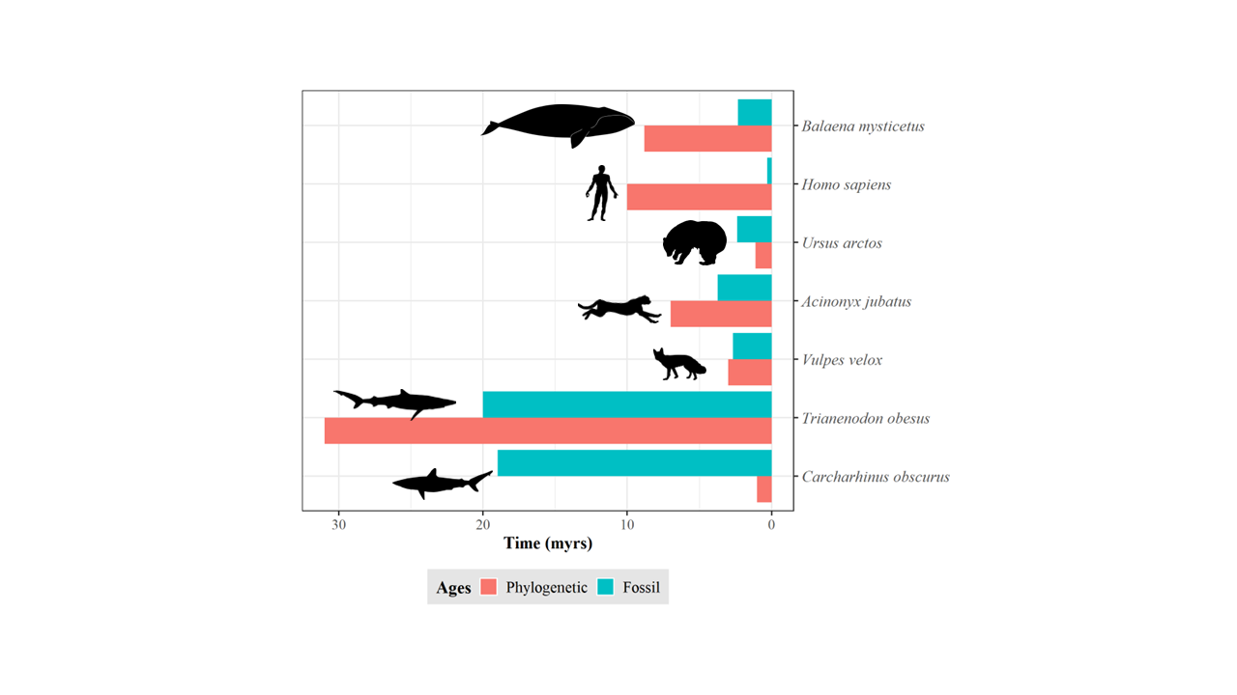

**Figure 1.** Discrepancy between species ages. Estimations based on the length of the terminal branch in a time-calibrated phylogeny (red) and the first appearance in the fossil record (green). Shark data (*Trianenodon obesus* and *Carcharhinus obscurus*) obtained from Brée et al. (2022). Mammals’ phylogenetic data (except *Homo sapiens*) obtained from Upham et al. (2019). Mammals’ fossil data (except *Homo sapiens*) obtained from Silvestro *et al.* (2018). *Homo sapiens* fossil and phylogenetic data obtained from Callaway (2017) and Rivas-Gonzáles et al. (2023), respectively.

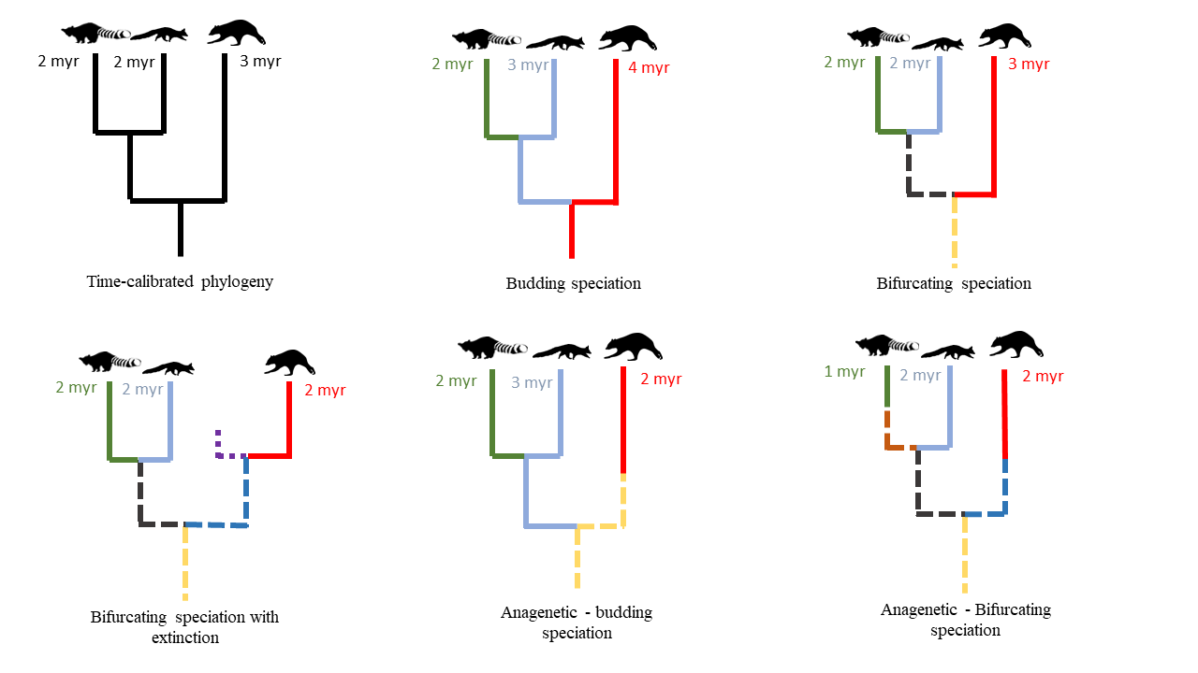

**Figure 2.** Impact of speciation mode and extinction on species age. For the same hypothetical time-calibrated phylogeny of extant species, the continuation of the same color indicates the same species, solid and dashed lines represent extant and extinct species, respectively, under different speciation modes and extinction scenarios. Numbers display the resulting age of the respective species in million years (myr).

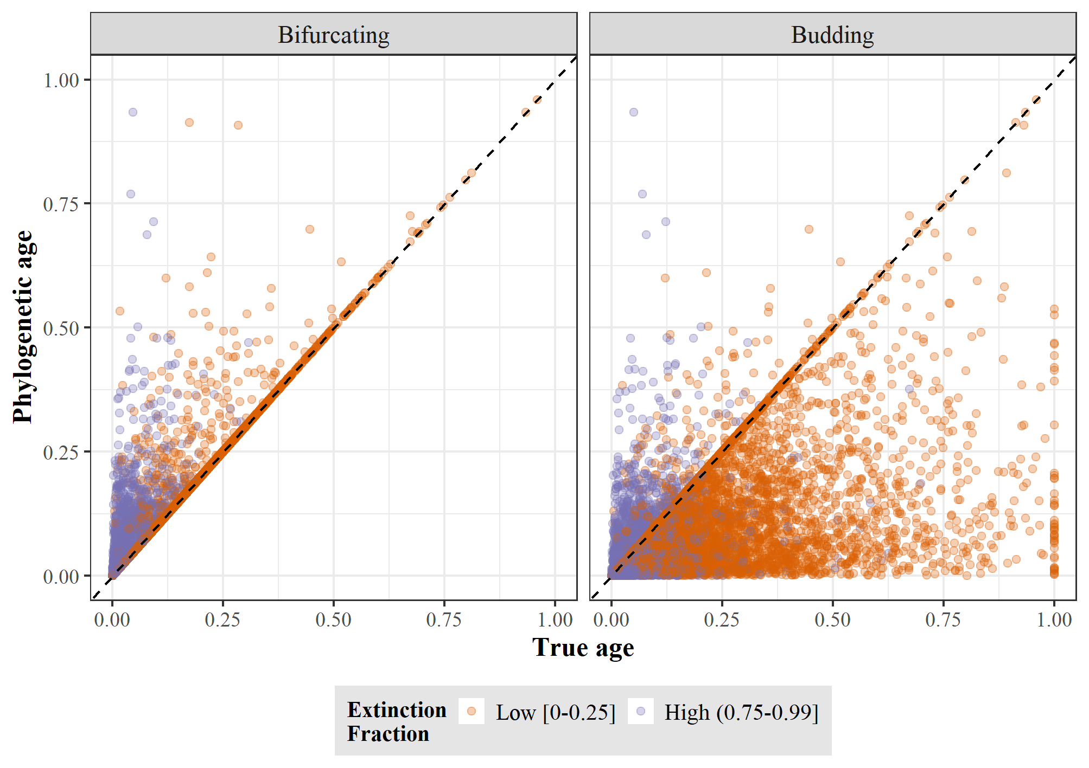

**Figure 3.** True age versus phylogenetic age at low and high extinction fraction for bifurcating (left) and budding (right) speciation. Each point represents a species and both ages, true and phylogenetic, are scaled to the root age of the correspondent phylogenetic tree.

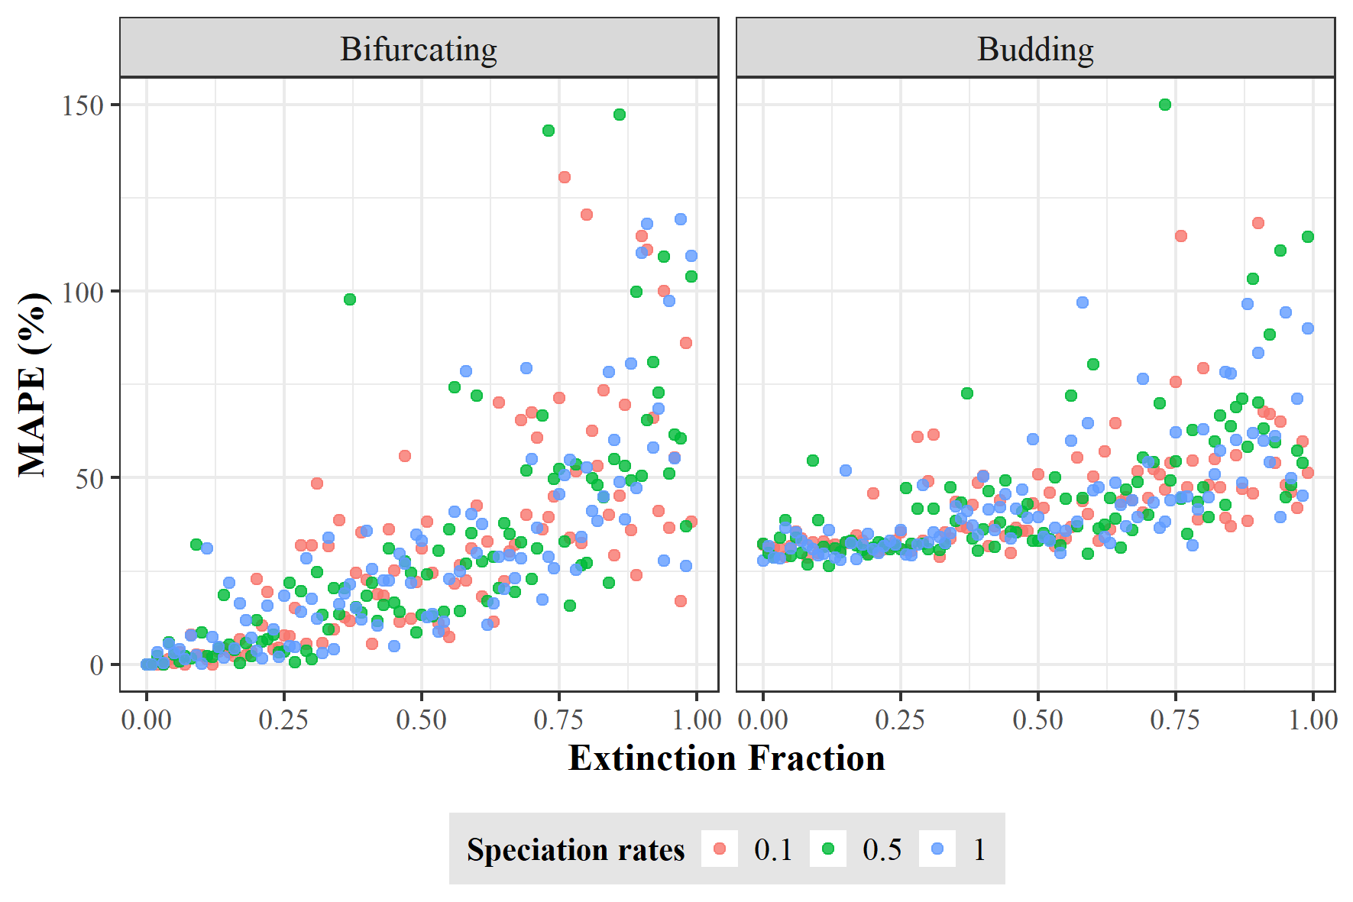

**Figure 4.** Error in equating phylogenetic age with speciation age. The error was quantified as mean absolute percentage error (MAPE) between the true and phylogenetic ages across all species for each tree simulated under bifurcating (left) and budding speciation (right). Each dot represents one replicate of the 300 trees for each speciation mode using different rates of speciation and extinction fraction.

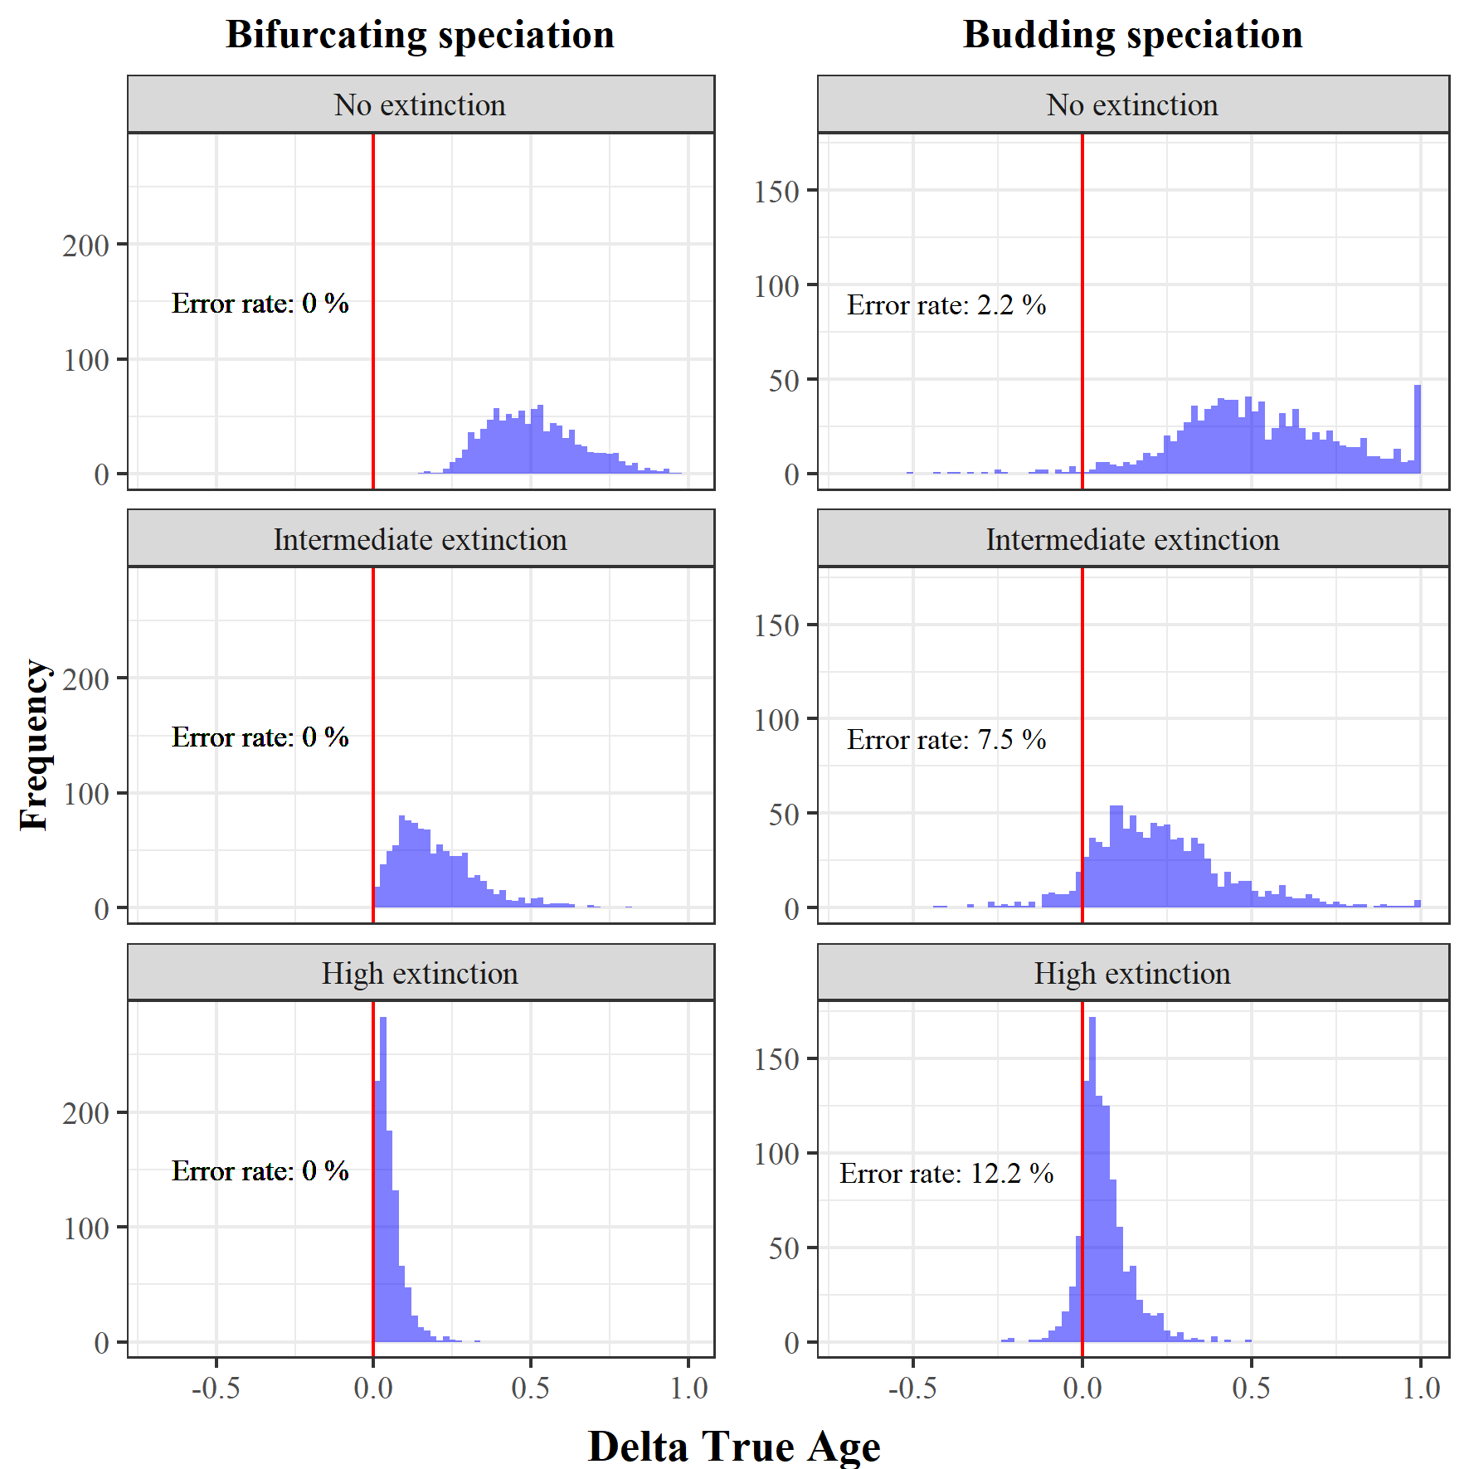

**Figure 5.** Error in estimating the relative age of species. For each of the 1000 simulations under bifurcating (left) and budding (right) speciation, combined with three different extinction levels, we selected the oldest and youngest species according to the phylogenetic ages, and calculated the difference in their true ages (ΔTrue age). A ΔTrue age smaller than 0 indicates that the phylogenetic oldest species was estimated to be in fact younger than the phylogenetic youngest species, and therefore, the comparison of phylogenetic ages is qualitatively wrong.

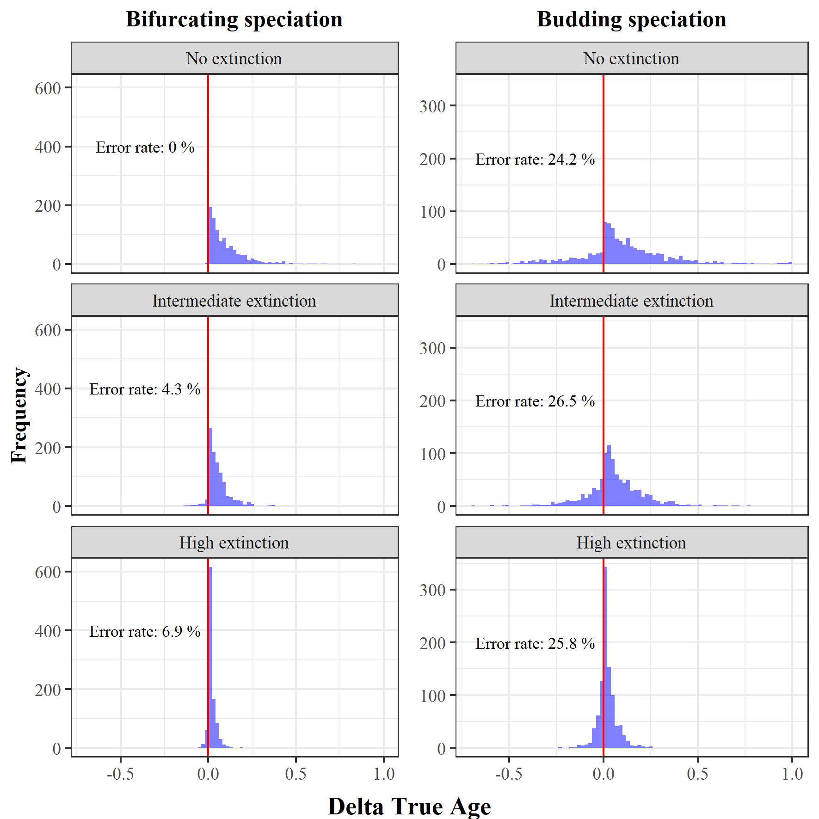

**Figure 6.** Risk to confuse older with younger random species. For each of the 1000 simulations under bifurcating (left) and budding (right) speciation, combined with three different extinction levels, we selected two random species and defined which was the older and younger according to the phylogenetic ages, and calculated the difference in their true ages (ΔTrue age). A ΔTrue age smaller than 0 indicates that the phylogenetic older species was in fact younger than the phylogenetic younger species, and therefore, the comparison of phylogenetic ages is qualitatively wrong.

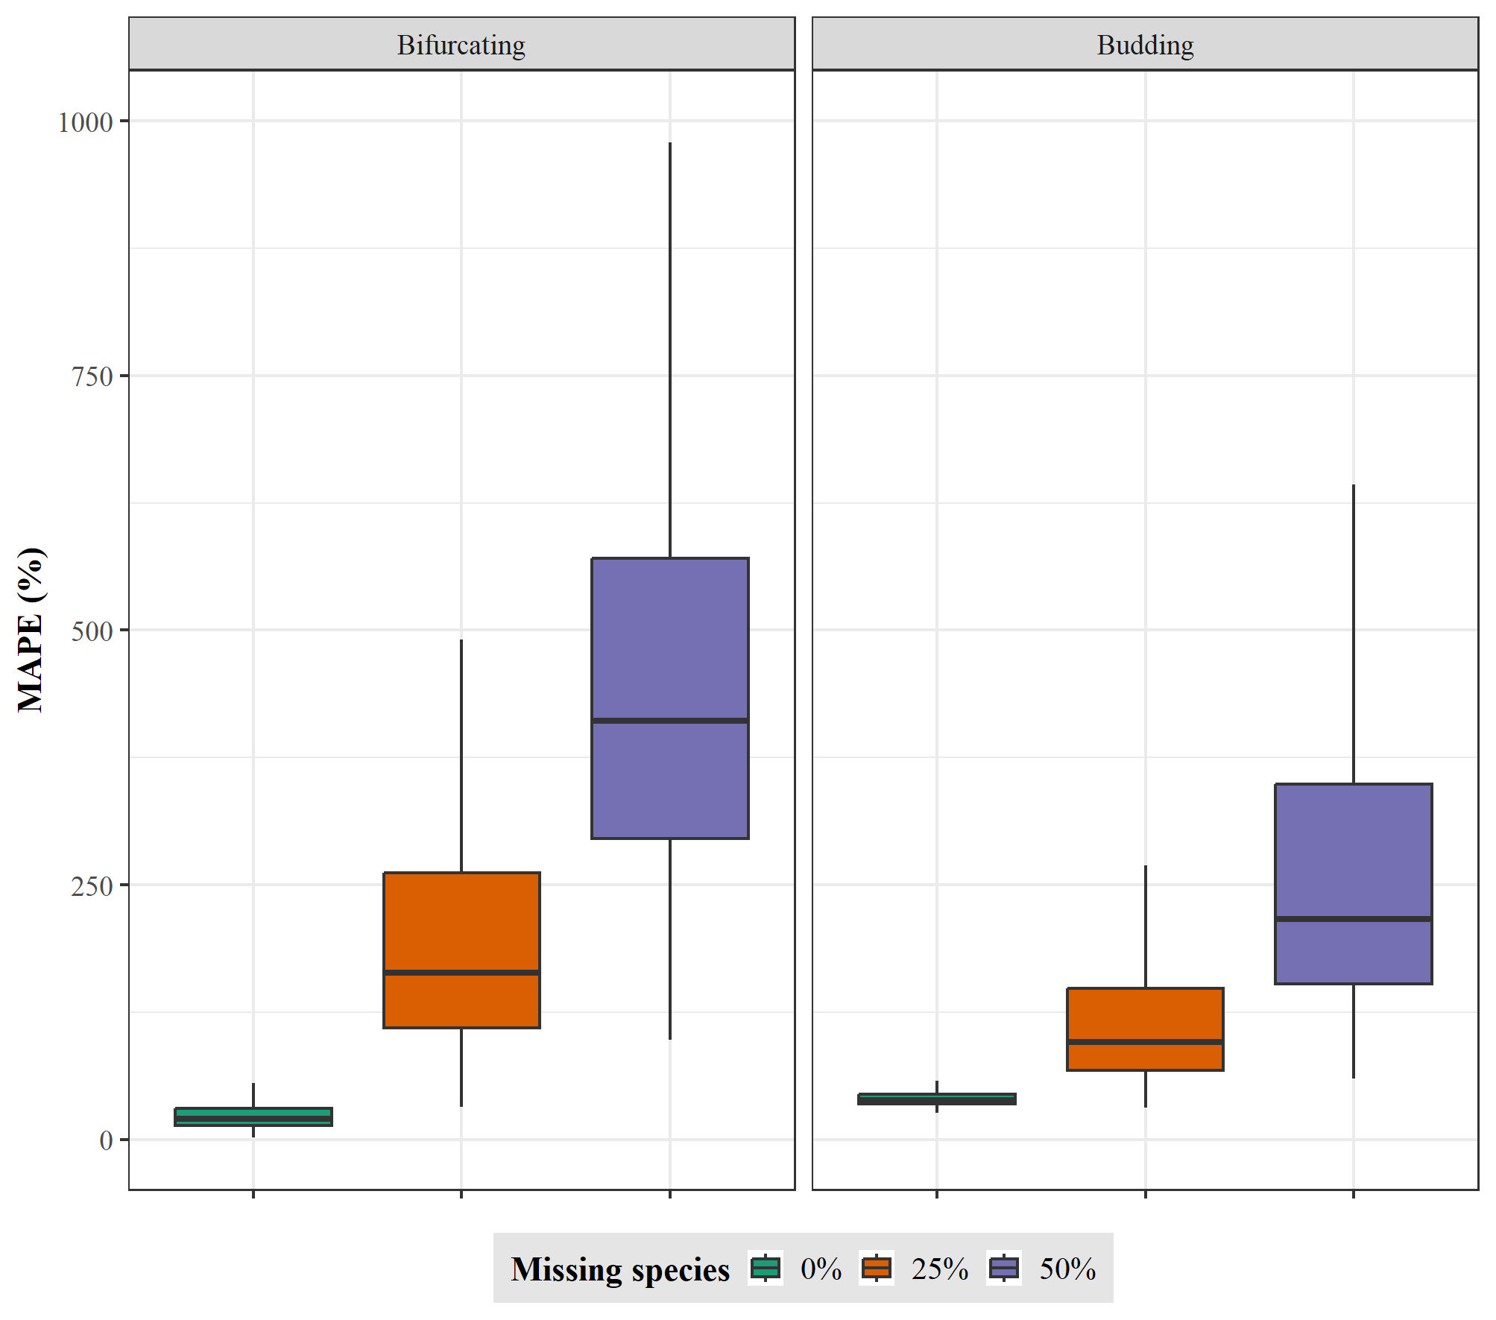

**Figure 7.** Error in equating the phylogenetic age with true species age for three levels of uniform incomplete sampling (0%, 25%, and 50% missing extant species; from left to right) with an intermediate extinction rate. The error was quantified as mean absolute percentage error (MAPE) between the true phylogenetic ages across 100 species for each of 1000 trees for each missing species scenario simulated under bifurcating (left) and budding (right) speciation.

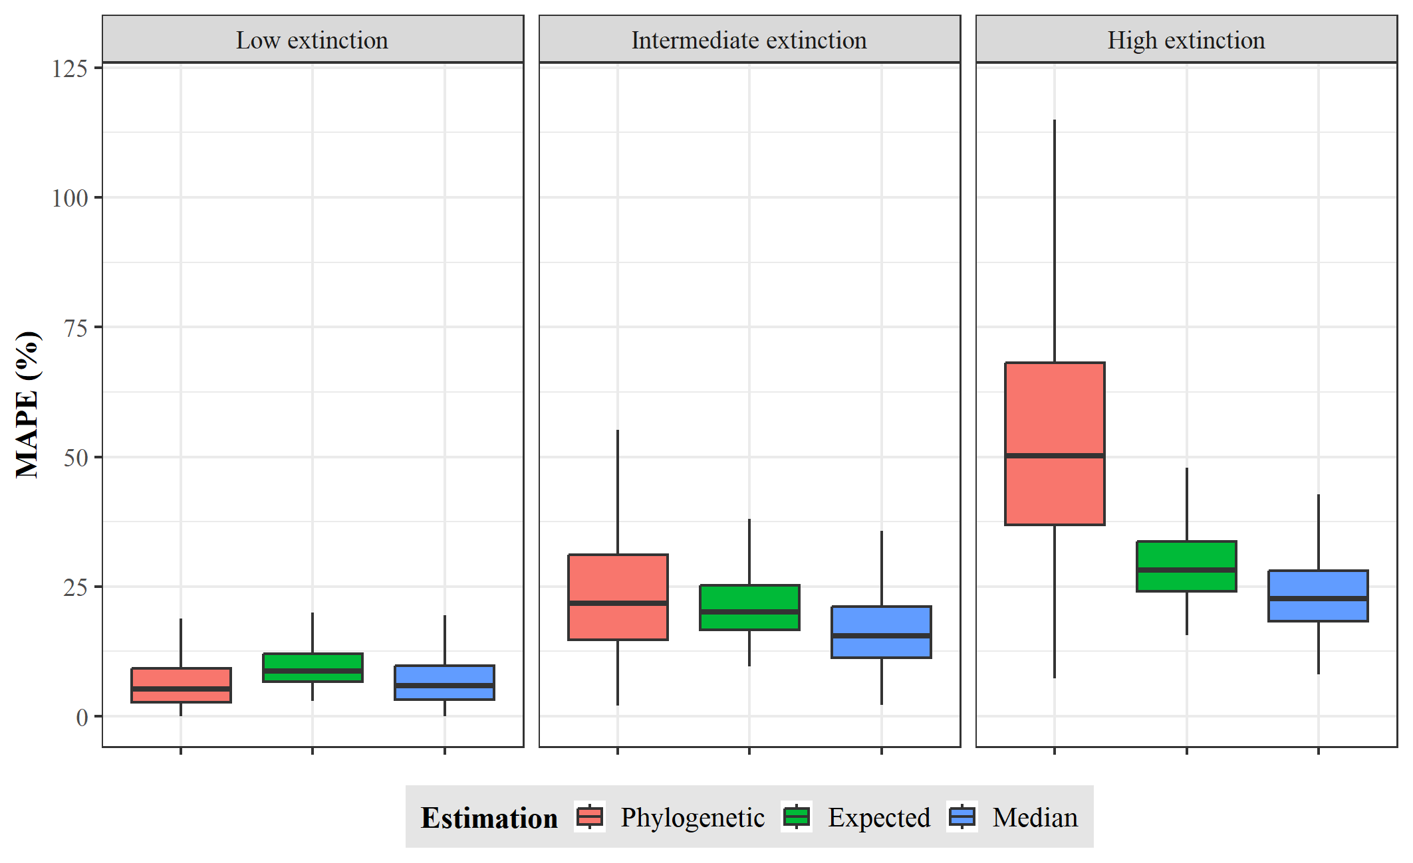

**Figure 8.** Error in equating the phylogenetic age and the probability estimator point estimates (Expected and Median) with true species age for three extinction scenarios (low, intermediate, and high; from left to right). The error was quantified as mean absolute percentage error (MAPE) between the true and point estimates or phylogenetic ages across 100 species for each of 1000 trees for each extinction scenario simulated under bifurcating speciation.

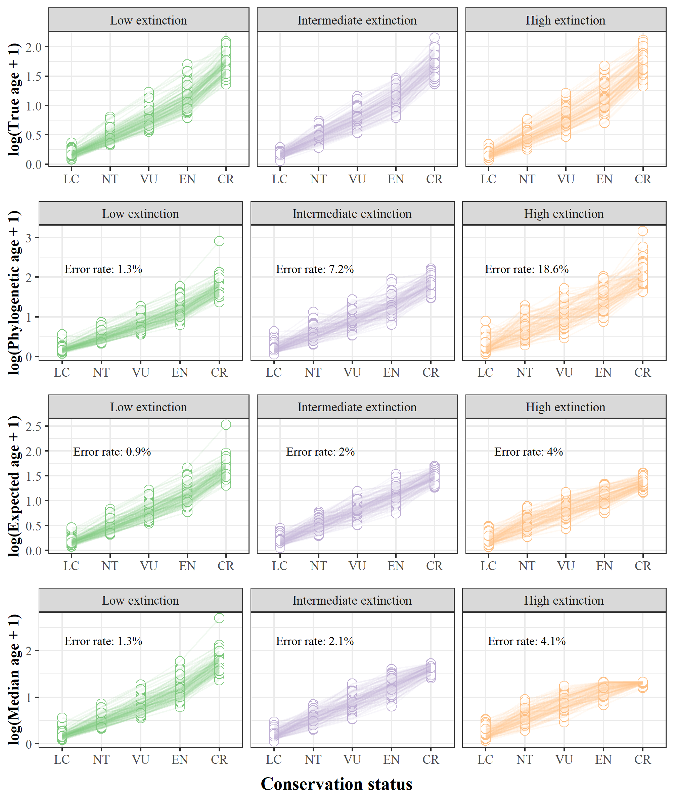

**Figure 9.** Positive Extinction signal comparison between Phylogenetic age, and the Expected and Median age generated by the bifurcating function, for three extinction scenarios (Low, Intermediate, and High) regarding the phylogeny simulation (1000 trees). Extinction signal is represented by the conservation status categories (LC = Least Concern; NT = Near Threatened; VU = Vulnerable; EN = Endangered; CR = Critically Endangered). The Error rate is based on the percentage of trees that were estimated wrong regarding the relationship between the True age and all the Conservation status categories.

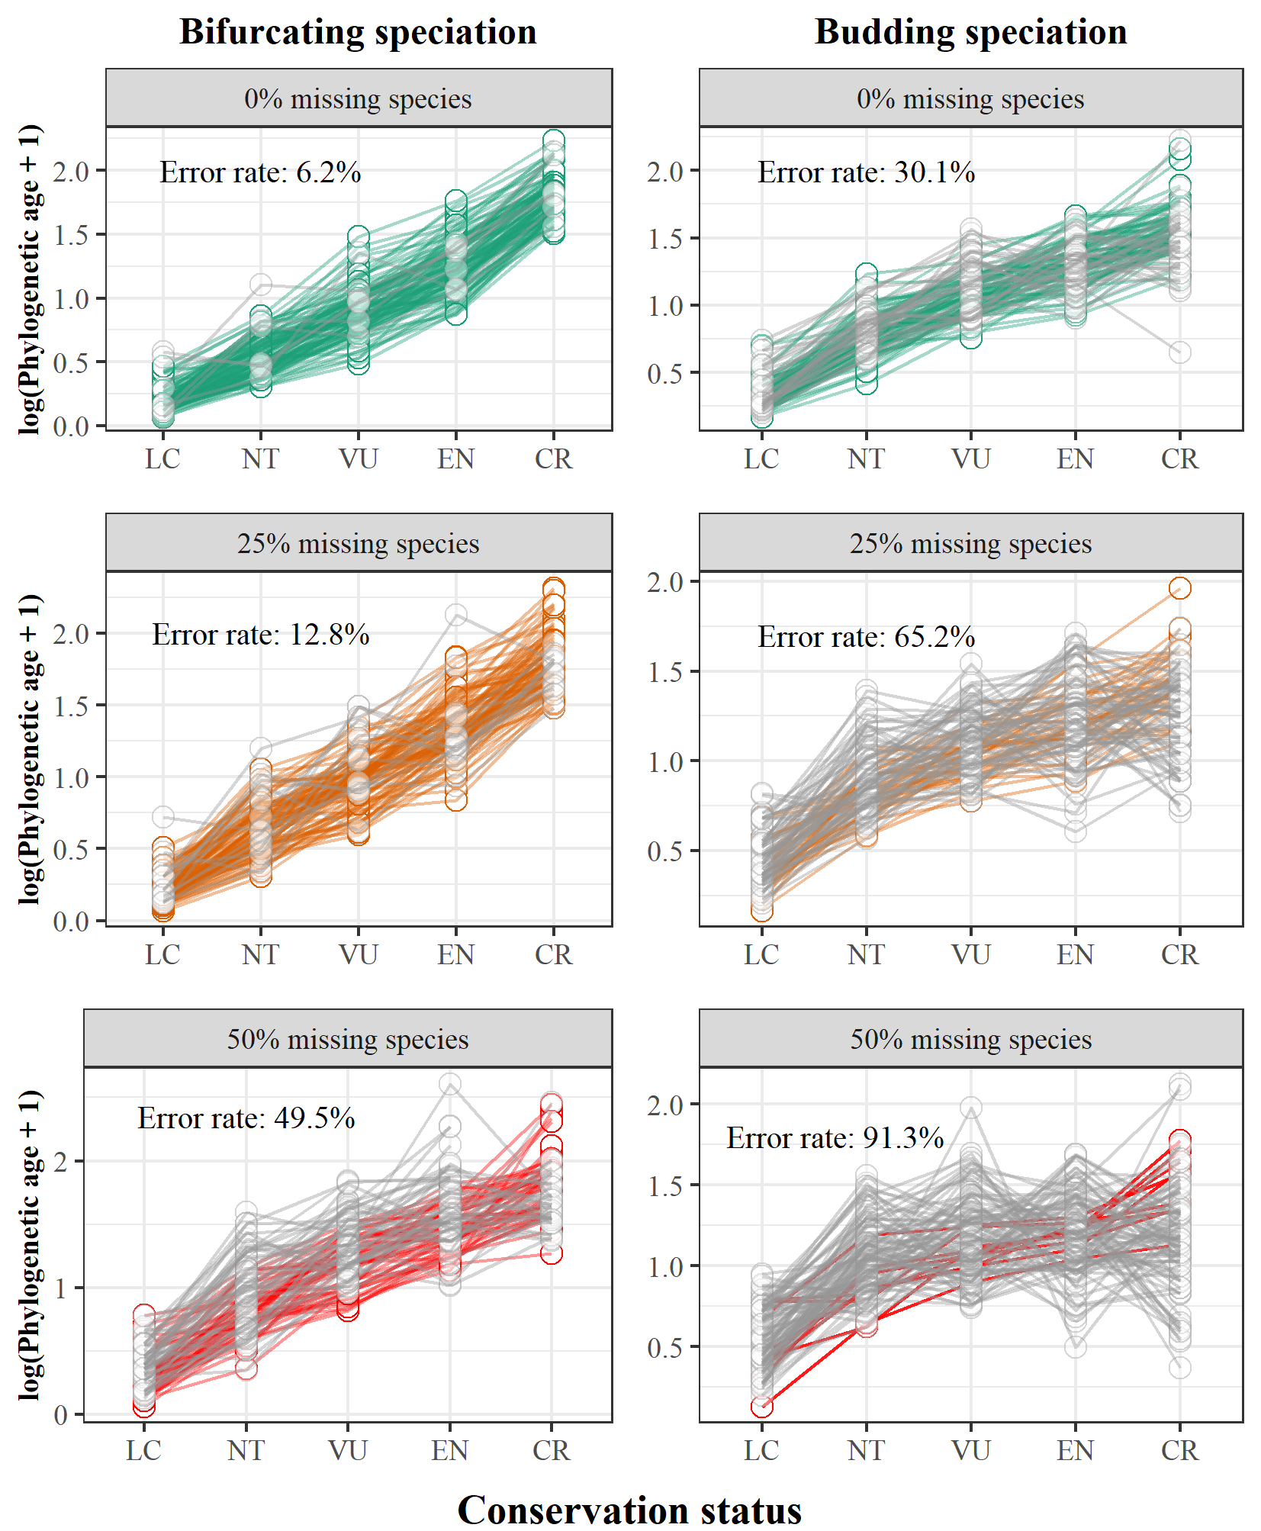

**Figure 10.** Positive Extinction signal demonstrations for trees assuming bifurcating (left) and budding (right) speciation, for three nonrandom incomplete sampling (older species are less likely to be sampled) levels (0%, 25%, and 50% missing extant species; from top to down). Extinction signal is represented by the conservation status categories (LC = Least Concern; NT = Near Threatened; VU = Vulnerable; EN = Endangered; CR = Critically Endangered). The Error rate is based on the percentage of trees that were estimated wrong regarding the relationship between the True age and all the Conservation status categories. Trees with the correct relationship are green (0% missing species), orange (25%), and red (50%). Trees with the incorrect relationship are gray.

**References**

Alroy, J., Marshall, C. R., Bambach, R. K., Bezusko, K., Foote, M., Fürsich, et al., (2001). Effects of sampling standardization on estimates of phanerozoic marine diversification. *Proceedings of the National Academy of Sciences of the United States of America*, *98*(11), 6261–6266. doi: 10.1073/pnas.111144698

Anacker, B. L., & Strauss, S. Y. (2014). The geography and ecology of plant speciation: Range overlap and niche divergence in sister species. *Proceedings of the Royal Society B: Biological Sciences*, *281*(1778). doi: 10.1098/rspb.2013.2980

Aze, T., Ezard, T. H. G., Purvis, A., Coxall, H. K., Stewart, D. R. M., Wade, B. S., & Pearson, P. N. (2011). A phylogeny of Cenozoic macroperforate planktonic foraminifera from fossil data. *Biological Reviews*, *86*(4), 900–927. doi: 10.1111/j.1469-185X.2011.00178.x

Balmford, A. (1996). Extinction filters and current resilience: The significance of past selection pressures for conservation biology. *Trends in Ecology and Evolution*. doi: 10.1016/0169-5347(96)10026-4

Barido-Sottani, J., Pett, W., O’Reilly, J. E., & Warnock, R. C. M. (2019). FossilSim: An r package for simulating fossil occurrence data under mechanistic models of preservation and recovery. *Methods in Ecology and Evolution*, *10*(6), 835–840. doi: 10.1111/2041-210X.13170

Barraclough, T. G., & Vogler, A. P. (2000). Detecting the geographical pattern of speciation from species-level phylogenies. *The American Naturalist*, *155*(4), 419–434. doi: 10.1086/303332

Barraclough, T. G., Vogler, A. P., & Harvey, P. H. (1998). Revealing the factors that promote speciation. *Philosophical Transactions of the Royal Society B: Biological Sciences*, *353*(1366), 241–249. doi: 10.1098/rstb.1998.0206

Baum, D. A., Smith, S. D. W., & Donovan, S. S. S. (2005). The tree-thinking challenge. *Science*, *310*(5750), 979–980. doi: 10.1126/science.1117727

Beaulieu, J. M., & O’Meara, B. C. (2016). Detecting hidden diversification shifts in models of trait-dependent speciation and extinction. *Systematic Biology*, *65*(4), 583–601. doi: 10.1093/sysbio/syw022

Benton, M. J. (2013). Origins of biodiversity. *Palaeontology*. doi: 10.1111/pala.12012

Benton, M. J. (2016). Origins of Biodiversity. *PLoS Biology*, *14*(11), 1–7. doi: 10.1371/journal.pbio.2000724

Brée, B., Condamine, F. L., & Guinot, G. (2022). Combining palaeontological and neontological data shows a delayed diversification burst of carcharhiniform sharks likely mediated by environmental change. *Scientific Reports*, *12*(1), 21906. doi: 10.1038/s41598-022-26010-7

Caetano, D. S., & Quental, T. B. (2022). How important is budding speciaiton for comparative studies? *BioRxiv*. doi: 10.1101/2022.05.24.493296

Caley, M. J., Fisher, R., & Mengersen, K. (2014). Global species richness estimates have not converged. Trends in Ecology & Evolution, 29(4), 187-188. doi:10.1016/j.tree.2014.02.002

Callaway, E. (2017). Oldest Homo sapiens fossil claim rewrites our species’ history. *Nature*, 546, 289-293. doi: 10.1038/nature.2017.22114

Carrillo, J. D., Faurby, S., Silvestro, D., Zizka, A., Jaramillo, C., Bacon, C. D., & Antonelli, A. (2020). Disproportionate extinction of South American mammals drove the asymmetry of the Great American Biotic Interchange. *Proceedings of the National Academy of Sciences of the United States of America*, *117*(42), 26281–26287. doi: 10.1073/pnas.2009397117

Carrillo, J. D., Forasiepi, A., Jaramillo, C., Sánchez-villagra, M. R., & Richardson, J. E. (2015). *Neotropical mammal diversity and the Great American Biotic Interchange : spatial and temporal variation in South America ’ s fossil record*. *5*(January), 1–11. doi: 10.3389/fgene.2014.00451

Chang, J., Rabosky, D. L., & Alfaro, M. E. (2020). Estimating Diversification Rates on Incompletely Sampled Phylogenies: Theoretical Concerns and Practical Solutions. *Systematic Biology*, *69*(3), 602–611. doi: 10.1093/sysbio/syz081

Davies, T. J., Smith, G. F., Bellstedt, D. U., Boatwright, J. S., Bytebier, B., Cowling, R. M., et al., (2011). Extinction risk and diversification are linked in a plant biodiversity hotspot. *PLoS Biology*. 9(5), e1000620. doi: 10.1371/journal.pbio.1000620

Diniz-Filho, J. A. F., Loyola, R. D., Raia, P., Mooers, A. O., & Bini, L. M. (2013). Darwinian shortfalls in biodiversity conservation. Trends in Ecology & Evolution, 28(12), 689-695. doi: 10.1016/j.tree.2013.09.003

Diniz Filho, J. A. F., Jardim, L., Guedes, J. J., Meyer, L., Stropp, J., Frateles, L. E. F., ... & Hortal, J. (2023). Macroecological links between the Linnean, Wallacean, and Darwinian shortfalls. *Frontiers of Biogeography*, 15(2). doi: 10.21425/F5FBG59566

Eldredge, N., Thompson, J. N., Brakefield, P. M., Gavrilets, S., Jablonski, D., Jackson, J. B. C., et al., (2005). The dynamics of evolutionary stasis. *Paleobiology* 31(S2), 133-145. doi: 10.1666/0094-8373(2005)031

Emerson, B. C., & Patiño, J. (2018). Anagenesis, Cladogenesis, and Speciation on Islands. *Trends in Ecology and Evolution*, *33*(7), 488–491. doi: 10.1016/j.tree.2018.04.006

Fitzpatrick, B. M., & Turelli, M. (2006). The Geography of Mammalian Speciation: Mixed Signals From Phylogenies and Range Maps. *Evolution*, *60*(3), 601–615. doi: 10.1111/j.0014-3820.2006.tb01140.x

Fjeldså, J., Bowie, R. C. K., & Rahbek, C. (2012). The role of mountain ranges in the diversification of birds. *Annual Review of Ecology, Evolution, and Systematics*, *43*, 249–265. doi: 10.1146/annurev-ecolsys-102710-145113

Foote, M. (1996). *On the Probability of Ancestors in the Fossil Record*. *22*(2), 141–151. doi: 10.1017/S0094837300016146

Foote, M., & Raup, D. M. (1996). *Fossil Preservation and the Stratigraphic Ranges of Taxa*. *22*(2), 121–140. doi: 10.1017/S0094837300016134

Gaston, K. J., & Blackburn, T. M. (1997). Evolutionary age and risk of extinction in the global avifauna. *Evolutionary Ecology,* 11, 557–565. doi: 10.1007/s10682-997-1511-4

Harvey, P. H., May, R. M., & Nee, S. (1994). Phylogenies without fossils. *Evolution*, *48*(3), 523–529. doi: 10.1111/j.1558-5646.1994.tb01341.x

Heath, T. A., Hedtke, S. M., & Hillis, D. M. (2008). Taxon sampling and the accuracy of phylogenetic analyses. *Journal of Systematics and Evolution*, *46*(3), 239–257. doi: 10.3724/SP.J.1002.2008.08016

Henning, W. (1999). *Phylogenetic systematics*. University of Illinois Press.

Hopkins, M. J. (2007). Modelling the known and unknown plant biodiversity of the Amazon Basin. *Journal of Biogeography*, 34(8), 1400-1411. doi: 10.1111/j.1365-2699.2007.01737.x

Hortal, J., de Bello, F., Diniz-Filho, J. A. F., Lewinsohn, T. M., Lobo, J. M., & Ladle, R. J. (2015). Seven shortfalls that beset large-scale knowledge of biodiversity. *Annual Review of Ecology, Evolution, and Systematics*, 46, 523-549. doi: 10.1146/annurev-ecolsys-112414-054400

IUCN. (2016). IUCN Red List of Threatened Species. Version 2016-2. *Fourth Quarter*.

Johnson, C. N., Delean, S., & Balmford, A. (2002). *Phylogeny and the selectivity of extinction in Australian marsupials*. 135–142. doi: 10.1017/S1367943002002196

Kendall, M. G. (1946). *The advanced theory of statistics* (2nd ed.). Charles Griffin adn Co., Ltd., London.

López-Martínez, A. M., Schonenberger, J., von Balthazar, M., González-Martínez, C. A., Ramírez-Barahona, S., Sauquet, H., & Magallón, S. (2023). Integrating Fossil Flowers into the Angiosperm Phylogeny Using Molecular and Morphological Evidence. *Systematic Biology*, *syad017*. doi: 10.1093/sysbio/syad017

Losos, J. B., & Glor, R. E. (2003). Phylogenetic comparative methods and the geography of speciation. *Trends in Ecology and Evolution*, *18*(5), 220–227. doi: 10.1016/S0169-5347(03)00037-5

Meier, R., & Willmann, R. (2000). A defense of the Hennigian Species Concept. In *Species concepts and phylogenetic theory: a debate* (p. 167).

Mynard, P., Algar, A., Lancaster, L., Bocedi, G., Fahri, F., Gubry-Rangin, C., et al., (2023). Impact of Phylogenetic Tree Completeness and Misspecification of Sampling Fractions on Trait Dependent Diversification Models. *Systematic Biology*, *72*(1), 106–119. doi: 10.1093/sysbio/syad001

Nee, S., & May, R. M. (1997). Extinction and the Loss of Evolutionary History. *Science*, *278*(5338), 692–694. doi: 10.1126/science.278.5338.692

Pearson, P. N. (1995). Investigating age-dependency of species extinction rates using dynamic survivorship analysis. *Historical Biology*, 10(2), 119–136. doi: 10.1080/10292389509380516

Pie, M. R., & Caron, F. (2023). Substantial variation in species ages among vertebrate clades. *BioRxiv*, *06*. doi: 10.1101/2023.06.08.544238

Pimm, S. L., Jenkins, C. N., Abell, R., Brooks, T. M., Gittleman, J. L., Joppa, L. N., … Sexton, J. O. (2014). The biodiversity of species and their rates of extinction, distribution, and protection. *Science*, *344*(6187). doi: 10.1126/science.1246752

R Core Team. (2019). R: A language and environment for statistical computing. Vienna, Austria: *R Foundation for Statistical Computing*. Retrieved from https://www.r-project.org/

Rabosky, D. L. (2010). Extinction rates should not be estimated from molecular phylogenies. *Evolution*, 64(6), 1816–1824. doi: 10.1111/j.1558-5646.2009.00926.x

Riddle, B. R., Ladle, R. J., Lourie, S. A., & Whittaker, R. J. (2011). Basic biogeography: estimating biodiversity and mapping nature. *Conservation biogeography*, 45-92. doi: 10.1002/9781444390001.ch4

Rivas-Gonzáles, I., Rousselle, M., Li, F., Zhou, L., Dutheil, J., Munch, K., et al., (2023). Pervasive incomplete lineage sorting illuminates speciation and selection in primates. *Science*, *380*(6648), eabn4409. doi: 10.1126/science.abn4409

Roopnarine, P. D., Byars, G., Fitzgerald, P., Paleobiology, S., & Winter, N. (1999). Anagenetic evolution, stratophenetic patterns, and random walk models. *Paleobiology,* 25(1), 41–57. doi: 10.1666/0094-8373(1999)0252.3.CO;2

Rosenblum, E. B., Sarver, B. A. J., Brown, J. W., Des Roches, S., Hardwick, K. M., Hether, T. D., et al., (2012). Goldilocks Meets Santa Rosalia: An Ephemeral Speciation Model Explains Patterns of Diversification Across Time Scales. *Evolutionary Biology*, *39*(2), 255–261. doi: 10.1007/s11692-012-9171-x

Silvestro, D., Salamin, N., & Schnitzler, J. (2014). PyRate: a new program to estimate speciation and extinction rates from incomplete fossil data. *Methods in Ecology and Evolution2*, *5*(10), 1126–1131. doi: 10.1111/2041-210X.12263

Silvestro, D., Castiglione, S., Mondanaro, A., Serio, C., Melchionna, M., Piras, P., et al., (2020). A 450 million years long latitudinal gradient in age-dependent extinction. *Ecology Letters*, *23*(3), 439–446. doi: 10.1111/ele.13441

Silvestro, D., Salamin, N., Antonelli, A., & Meyer, X. (2019). Improved estimation of macroevolutionary rates from fossil data using a Bayesian framework. *Paleobiology*, *45*(4), 546–570. doi: 10.1017/pab.2019.23

Silvestro, D., Warnock, R. C. M., Gavryushkina, A., & Stadler, T. (2018). Closing the gap between palaeontological and neontological speciation and extinction rate estimates. *Nature Communications*, *9*(1). doi: 10.1038/s41467-018-07622-y

Simpson, George Gaylord. (1961). *Principles of animal taxonomy*. Columbia University Press.

Simpson, George Gaylord. (1984). *Tempo and mode in evolution*. Columbia University Press.

Simpson, Geroge G. (1951). The species concept. *Evolution*, *5*(4), 285–298.

Skeels, A., & Cardillo, M. (2019). Reconstructing the geography of speciation from contemporary biodiversity data. *American Naturalist*, *193*(2), 240–255. doi: 10.1086/701125

Slater, G. J., & Harmon, L. J. (2013). Unifying fossils and phylogenies for comparative analyses of diversification and trait evolution. *Methods in Ecology and Evolution*, 4(8), 699-702. doi: 10.1111/2041-210X.12091

Sonne, J., Dalsgaard, B., Borregaard, M. K., Kennedy, J., Fjeldså, J., & Rahbek, C. (2022). Biodiversity cradles and museums segregating within hotspots of endemism. *Proceedings of the Royal Society B: Biological Sciences*, *289*(1981), 20221102. doi: 10.1098/rspb.2022.1102

Stadler T (2019). TreeSim: Simulating Phylogenetic Trees. R package version

2.4, https://CRAN.R-project.org/package=TreeSim

Swenson, N. G. (2019). *Phylogenetic ecology: A history, critique, and remodeling*. University of Chicago Press.

Tanentzap, A. J., Brandt, A. J., Smissen, R. D., Heenan, P. B., Fukami, T., & Lee, W. G. (2015). When do plant radiations influence community assembly? The importance of historical contingency in the race for niche space. *New Phytologist*, *207*(2), 468–479. doi: 10.1111/nph.13362

Tanentzap, A. J., Igea, J., Johnston, M. G., & Larcombe, M. J. (2020). Does evolutionary history correlate with contemporary extinction risk by influencing range size dynamics? *American Naturalist*, 195(3), 569–576. doi: 10.1086/707207

Thomas, G. H., Hartmann, K., Jetz, W., Joy, J. B., Mimoto, A., & Mooers, A. O. (2013). PASTIS: An R package to facilitate phylogenetic assembly with soft taxonomic inferences. *Methods in Ecology and Evolution*, *4*(11), 1011–1017. doi: 10.1111/2041-210X.12117

Upham, N. S., Esselstyn, J. A., & Jetz, W. (2019). Inferring the mammal tree: Species-level sets of phylogenies for questions in ecology, evolution, and conservation. In *PLoS Biology*, 17(12), e3000494. doi: 10.1371/journal.pbio.3000494

Van Valen, L. (1973). A new evolutionary law. *Evolutionary Theory*. 1, 1–30.

Verde Arregoitia, L. D., Blomberg, S. P., & Fisher, D. O. (2013). Phylogenetic correlates of extinction risk in mammals: Species in older lineages are not at greater risk. *Proceedings of the Royal Society B: Biological Sciences* 280(1765), 20131092. doi: 10.1098/rspb.2013.1092

Vilela, B., Villalobos, F., Rodríguez, M. Á., & Terribile, L. C. (2014). Body size, extinction risk and knowledge bias in New World snakes. PloS one, 9(11), e113429. doi: 10.1371/journal.pone.0113429

Wagner, P. J., Erwin, D. H., & Anstey, R. L. (1995). Phylogenetic patterns as tests of speciation models. In *New approaches to speciaiton in the fossil record* (pp. 87–122). New York: Columbia University Press.

Willmann, R., & Meier, R. (2000). A critique from the Hennigian species concept perspective. In *Species concepts and phylogenetic theory: a debate* (pp. 101–118). New York: Columbia University Press.